Business Report

Lavanya Sreeram

DSBA, Nov202 Batch

Business Report

Predictive Modeling



Contents

List Of Figures: 2

List of Tables: 2

Data and Data Dictionary: 3

**1** **Problem 1: Linear Regression** 4

**2** **Problem 2: Logistic Regression, LDA, CART** 9

# List Of Figures:

|  |  |  |  |
| --- | --- | --- | --- |
| **S No** | **Name** | **Description** | **Source** |
| 1 | Fig1 | Cover Page Picture | https://www.techrepublic.com/article/types-of-predictive-modeling/ |
| 2 | Fig2 | Linear Regression Data Dictionary | Provided Dataset. |
| 3 | Fig3 | Logistic Regression, LDA, CART Data Dictionary | Provided Dataset. |
| 4 | Fig1.1.1 | Linear Regression: Dataset Head | EDA |
| 5 | Fig1.1.2 | Linear Regression: Dataset Info | EDA |
| 6 | Fig1.1.3 | Linear Regression: Dataset Description | EDA |
|  | Fig1.1.4 | Linear Regression: pairplot | EDA |
| 7 | Fig1.2.1 | Boxplot of 'rchar' | Data Preparation |
| 8 | Fig1.2.2 | Boxplot of 'wchar' | Data Preparation |
| 9 | Fig1.2.3 | Linear regression: Outliers | Data Preparation |
| 10 | Fig1.3.1 | Linear Regression:Encoding 'runqsz' | Modeling |
| 11 | Fig1.3.2 | Linear Regression: Train Dataset Head | Modeling |
| 12 | Fig1.3.3 | Linear Regression: Test Dataset Head | Modeling |

# List of Tables:

# **Problem 1: Linear Regression**

* 1. Read the data and do exploratory data analysis. Describe the data briefly. (Check the Data types, shape, EDA, 5-point summary). Perform Univariate, Bivariate Analysis, Multivariate Analysis.

Answer:

[**compactiv.xlsx**](https://olympus.mygreatlearning.com/courses/87096/files/7893736/download?verifier=TCpmq4yoebLUFGKipnw3qw5EMfxqmYsU6VrePR5A&wrap=1)data set is provided. The given Data Dictionary is as shown below.  
  
The Dataset has 8192 rows, 22 columns. ‘usr’ is the Target Variable. The below figure shows the dataset top 5 rows (Fig1.1.1).

Most of the columns in the data are numeric in nature ('int64' or 'float64' type). 'runqsz' is object type. The below figure shows the datatypes of the columns (Fig1.1.2).

The statistical data descriptions is as shown in below figure.(Fig1.1.3)  
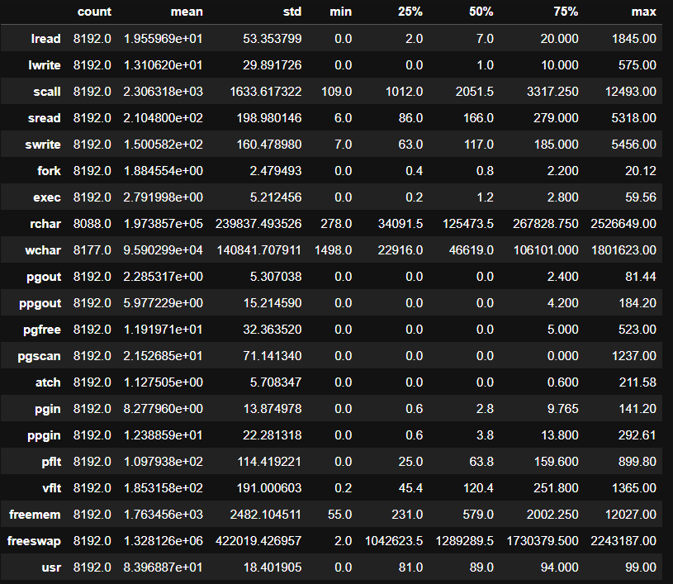

Bivariate analysis is performed on the data and the pairplot is shown below (Fig 1.1.4):  
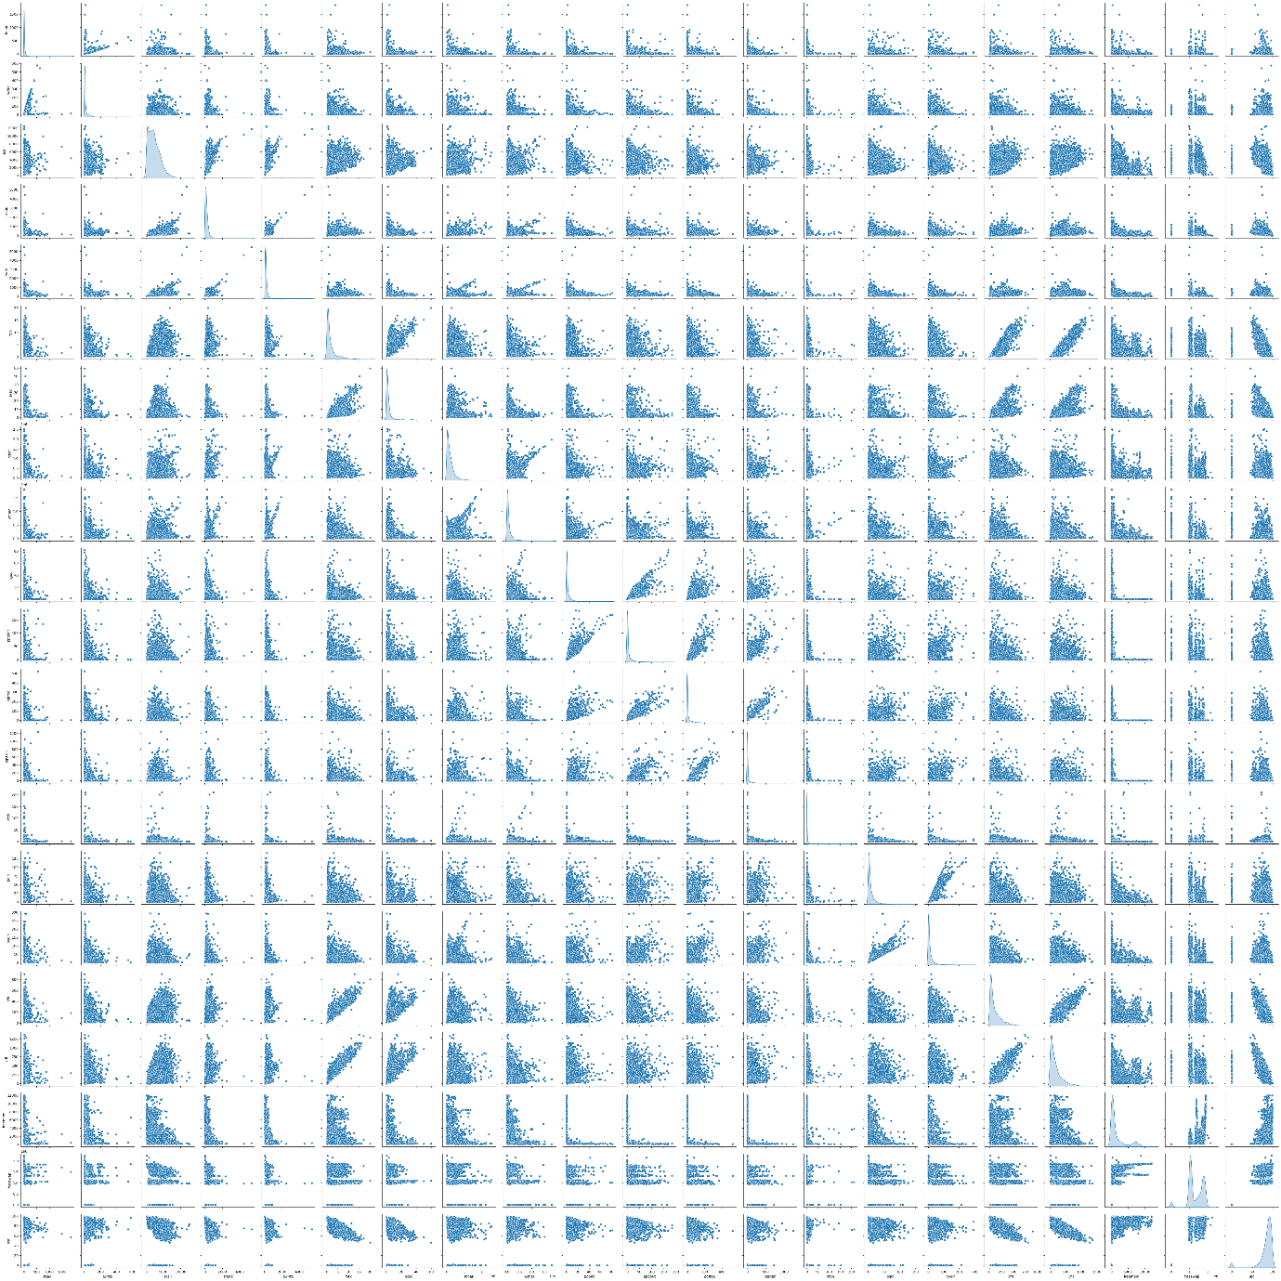

* 1. Impute null values if present, also check for the values which are equal to zero. Do they have any meaning, or do we need to change them or drop them? Check for the possibility of creating new features if required. Also check for outliers and duplicates if there.

Answer:

There are no duplicates in the data. There are 104 null values in ‘rchar’ column, 15 in ‘wchar’ column respectively. The data in both these columns is skewed as seen in boxplots below (Fig1.2.1).  
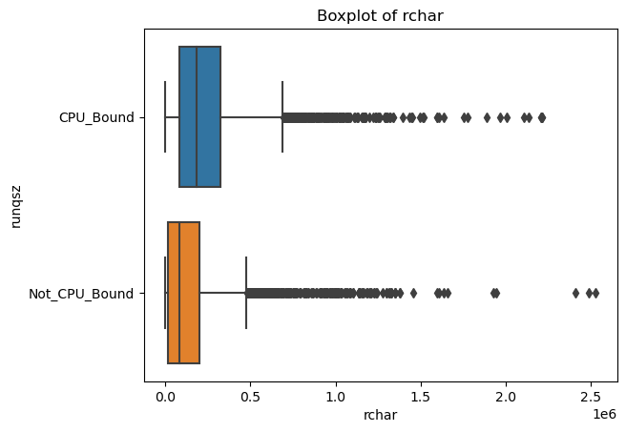

Fig(1.2.2)

The missing values in ‘rchar’, ‘wchar’ columns are treated by median imputation. Median imputation is preferred when the distribution is skewed, as the median is less sensitive to outliers than the mean.

There are multiple outliers in many columns as shown in below figure (Fig1.2.3).

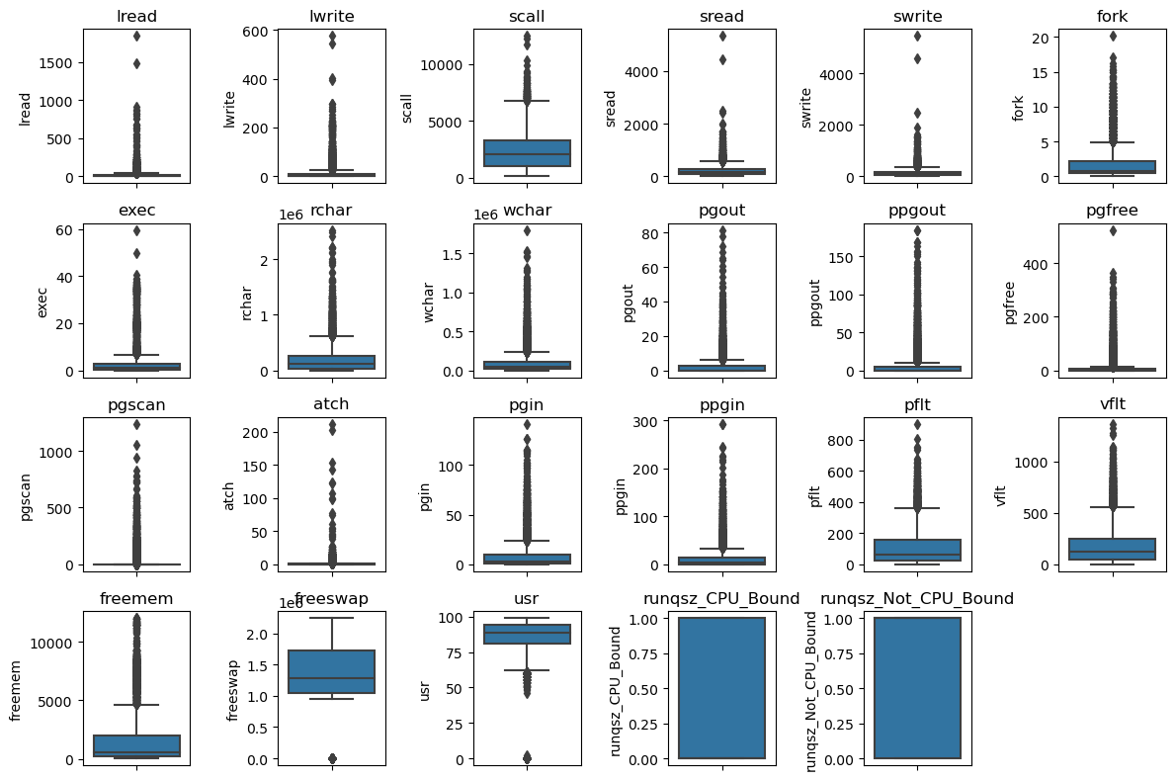

Treat outliers:

The outliers shall be treated via standard Q1 - 3 * IQR or Q3 + 3 * IQR method. There are outliers in the dataset as shown in below boxplot (Fig1.3.1)  
  
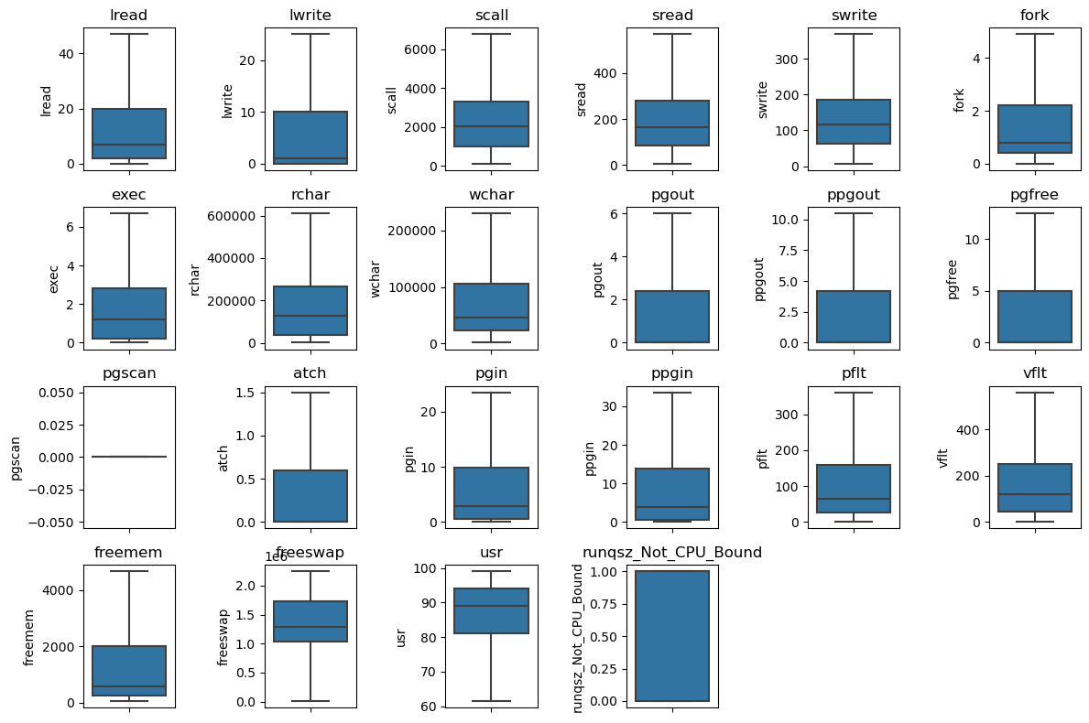

The below chart shows there is lots of multi-collinearity and co-relation between variables , before treating outliers.  
Even after treating outliers, below co-relation exists:

* 1. Encode the data (having string values) for Modelling. Split the data into train and test (70:30). Apply Linear regression using scikit learn. Perform checks for significant variables using appropriate method from statsmodel. Create multiple models and check the performance of Predictions on Train and Test sets using Rsquare, RMSE & Adj Rsquare. Compare these models and select the best one with appropriate reasoning.

Answer:  
Encoding:

The ‘runqsz’ feature is the only categorical feature and contains binary values. After one-hot encoding, the dataset looks like below figure (Fig1.3.1).

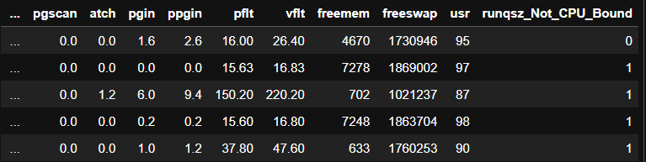

VIF:

Using VIF, important features are extracted. The below figure shows the sorted eatures by Importance.  
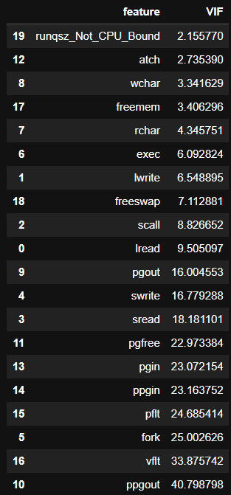

The features with Imp above 10 are considered for linear regression model.

Split Data:  
The ‘usr’ column is target variable y. Rest of the data is X. The data X and y is split into train and test sets in a 70:30 ratio. The Train dataset top 5 rows are shown below (Fig1.3.2).

The test dataset top 5 rows are shown below (Fig1.3.3).

The training and test dataset sample for ols stats model is shown below:  
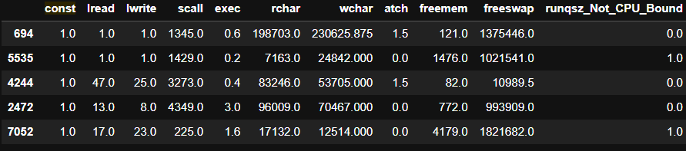

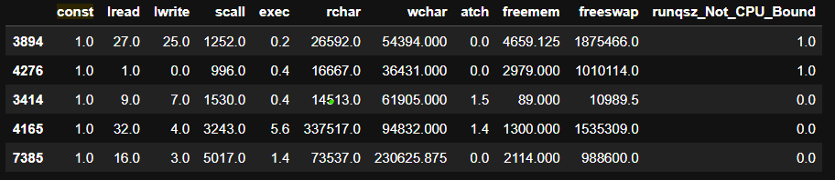

Below snapshots show the sample train and test data used for linear regression:

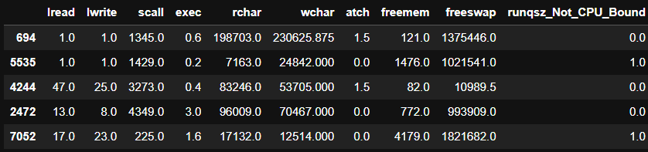

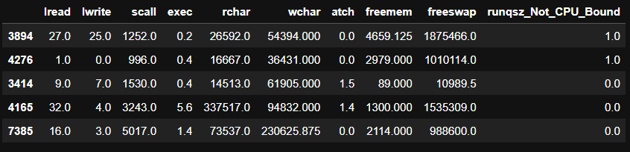

* 1. Inference: Basis on these predictions, what are the business insights and recommendations. Please explain and summarise the various steps performed in this project. There should be proper business interpretation and actionable insights present.

Answer:

Scikit-learn model RMSE: 4.652295704193024

OLS stats model RMSE: 4.652295704193209

The model co-efficient and intercept are given below for linear regression model.  
Coefficients: [[-6.34815062e-02 4.81612871e-02 -6.63828011e-04 3.08252103e-04

-5.42182230e-03 2.93127272e-02 -3.21166484e-01 -5.16684176e-06

-5.40287524e-06 -3.68819064e-01 -7.65976821e-02 8.44841447e-02

6.27574157e-01 1.99879077e-02 -6.73338398e-02 -3.36028294e-02

-5.46366880e-03 -4.58467188e-04 8.83184026e-06 1.61529785e+00]]

Intercept: [84.1217408]

----

Finally, After dropping the Features with VIF high, t**he Linear regression model gives below results for performance:**

Training set performance:

RMSE: 4.420

R-squared: 0.796

MSE 21.643855319252868

Test set performance:

RMSE: 4.652

R-squared: 0.768

MSE 19.532299277152052

These values are good.

# **Problem 2: Logistic Regression, LDA, CART**

* 1. Data Ingestion: Read the dataset. Do the descriptive statistics and do null value condition check, check for duplicates and outliers and write an inference on it. Perform Univariate and Bivariate Analysis and Multivariate Analysis.

Answer:  
Data Description:

[**Contraceptive_method_dataset.xlsx**](https://olympus.mygreatlearning.com/courses/87096/files/7893734/download?verifier=HeuusfY52K3brnnpI6fXBmVuhzyAVT1AKTfTT9mN&wrap=1) **data set is provided. The given Data Dictionary is shown below.**Text

The data has 1473 rows, 10 columns. ‘Contraceptive_method_used’ is the target or feature of interest with ‘Yes’ having higher value count and hence the positive class.

Sample Data:

The Data provided has these top rows as shown below.  
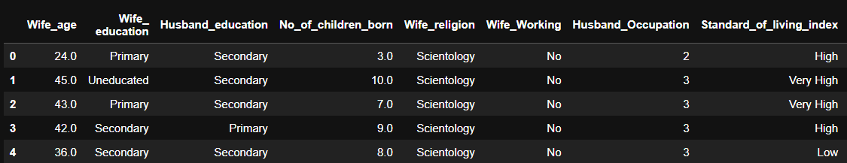

The bottom five rows from the dataset are shown below.

The data contains many numerical and categorical columns. Further exploratory data analysis is as below.

Exploratory Data Analysis:  
The datatype of each feature is shown below:  
Wife_age float64

Wife_ education object

Husband_education object

No_of_children_born float64

Wife_religion object

Wife_Working object

Husband_Occupation int64

Standard_of_living_index object

Media_exposure object

Contraceptive_method_used object

Inference: Out of 10 columns 7 are type object, rest are either of type float or integer. Most of the existing *numerical* columns are of type float64, int64 already.

'Husband_Occupation' data type is already encoded from categorical variable. Categorical columns like Education (both 'Wife_ education', 'Husband_education'), 'Wife_religion', ‘Wife_Working' , 'Standard_of_living_index', 'Media_exposure', 'Contraceptive_method_used' are object type.

'Media_exposure ', 'Wife_Working', 'Wife_religion' columns will be converted to numerical by one-hot encoding process.

‘Contraceptive_method_used’, ‘Wife_ education’, ‘Husband_education’, ‘Standard_of_living_index’ shall be converted to numerical by using the data description provided in data inputs.

Additionally, ‘'Wife_ education' can be renamed as ‘Wife_education', and ‘Media_exposure ‘ as ‘Media_exposure so as to remove the white space in the feature name.

Missing values:

Below information shows the missing values in the data.  
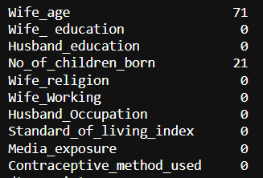  
There are 71 missing values in ‘Wife_age’ column, 21 missing values in ‘No_of_children_born’ column.  
Data description is shown below:  
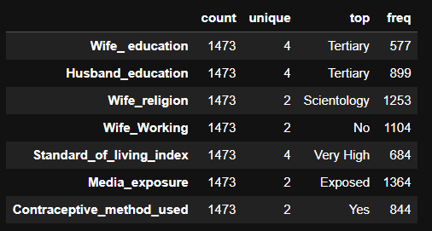

At first look, for most frequent/top observations for ‘Wife_ education’ and ‘Husband_education’ are tertiary. Standard of living is high, Contraceptive used is Yes. Need to perform regression to understand more insights from the dataset.

Below are the outliers before treating / encoding the data.

Highest outliers are present in no of children. These outliers shall be ignored for now as these are very small number of outliers. Outliers in more features can be understood as the data is converted from categorical to numerical.

* 1. Do not scale the data. Encode the data (having string values) for Modelling. Data Split: Split the data into train and test (70:30). Apply Logistic Regression and LDA (linear discriminant analysis) and CART.

Answer:

The features that have categorical data needed to be converted to numerical, and also features are converted to int/float. Numerical conversion of data is performed using the data description provided. 'Wife_Working', 'Wife_religion' columns will be converted to numerical by one-hot encoding process.

‘Contraceptive_method_used’, ‘Wife_ education’, ‘Husband_education’, 'Media_exposure ', ‘Standard_of_living_index’ shall be converted to numerical by using the data description provided in data inputs. Additionally, the columns are now of numerical type. Data type of the dataset is shown below: Text

Sample dataset after encoding is shown below:

The pairplot is shown below:

The dataset now has all numerical values.

The univariate and bivariate analysis shows the below charts:

After treating/encoding the features as numerical, there are outliers in no of children, standard of living. The outliers are shown below.

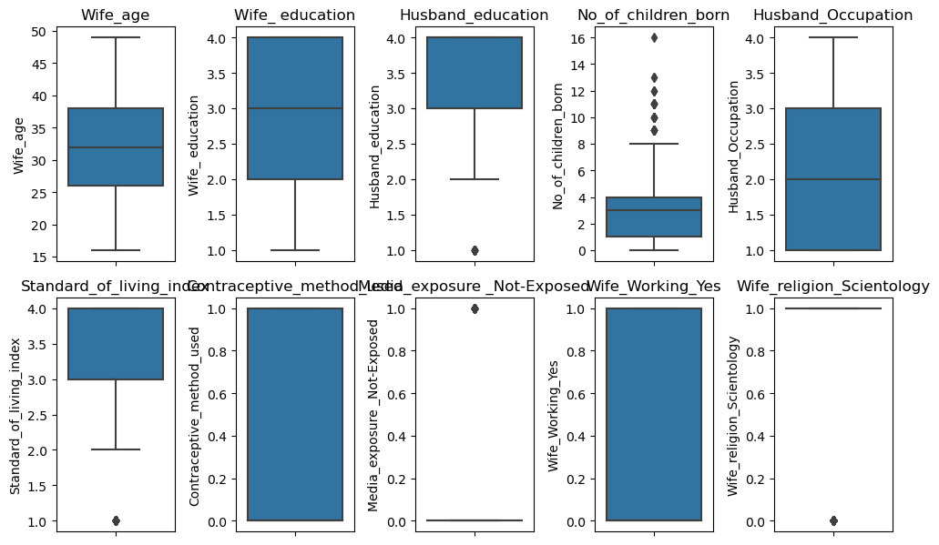

After treating outliers using the IQR+1.5 rule, we find the boxplot as below with no outliers:  
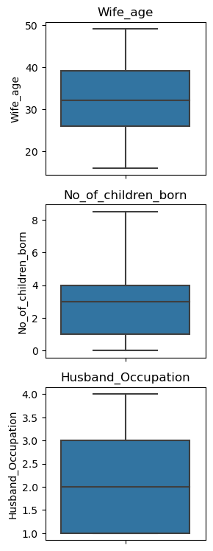

Using sklearn train test split method, the dataset is split into 70 30 for training and testing using random state 1 to replicate results.

The sample train dataset is shown below:   
The sample test dataset is shown below:

However..  
The dataset has lot of corelation & multi collinearity as shown in below heatmaps and VIF Importance.

The VIF importance sorted shall look like:  


Drop the features with high vif and below corelation heat map is shown:  
Decision trees is as below:

Logistic Regression, LDA, CART are applied on the dataset using training and performance is checked using the test data.

Hyper parameters used for the models are max_iter=1000 in Logistic regression, n_components=1 in LDA, criterion=’gini’ in CART.

Drop these features with high VIF:

'No_of_children_born','Husband_education','Wife_age','Wife_education','Standard_of_living_index','Media_exposure_1'.  
Then train data will look like:  
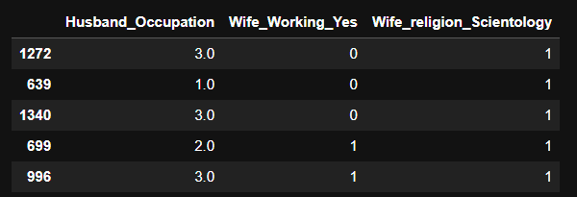

Test data sample shall look like:  
s

* 1. Performance Metrics: Check the performance of Predictions on Train and Test sets using Accuracy, Confusion Matrix, Plot ROC curve and get ROC_AUC score for each model Final Model: Compare Both the models and write inference which model is best/optimized.

When the model is run without any treatment of Feature Importances or multi -collinearity, below are the classification results.  
Classification Report of Train Data using Logistic Regression:

precision recall f1-score support

0.0 0.68 0.53 0.59 424

1.0 0.69 0.81 0.74 542

accuracy 0.69 966

macro avg 0.68 0.67 0.67 966

weighted avg 0.69 0.69 0.68 966

Classification Report of Test Data using Logistic Regression:

precision recall f1-score support

0.0 0.69 0.50 0.58 205

1.0 0.62 0.78 0.69 210

accuracy 0.64 415

macro avg 0.65 0.64 0.63 415

weighted avg 0.65 0.64 0.63 415

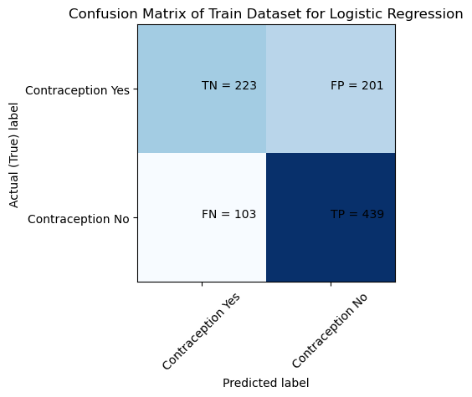

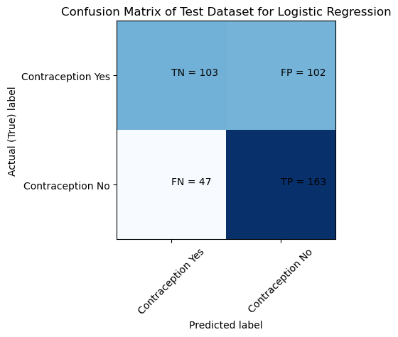

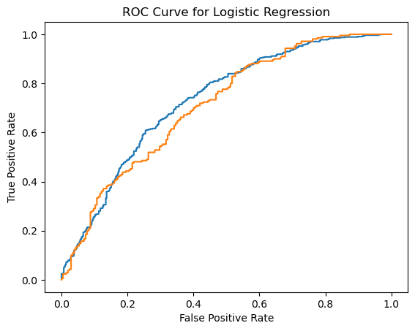

------

Classification Report of Train Data using LDA:

precision recall f1-score support

0.0 0.69 0.51 0.58 424

1.0 0.68 0.82 0.74 542

accuracy 0.68 966

macro avg 0.68 0.66 0.66 966

weighted avg 0.68 0.68 0.67 966

Classification Report of Test Data using LDA:

precision recall f1-score support

0.0 0.68 0.49 0.57 205

1.0 0.61 0.78 0.68 210

accuracy 0.64 415

macro avg 0.65 0.63 0.63 415

weighted avg 0.65 0.64 0.63 415

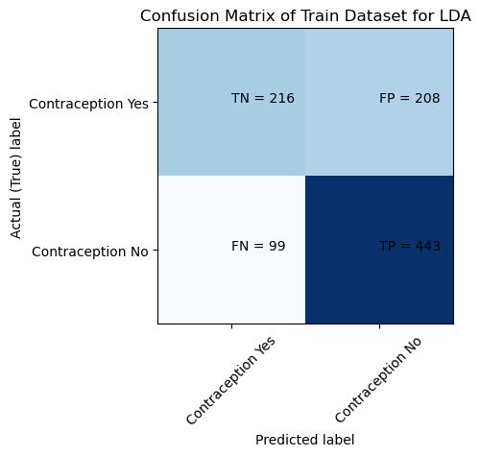

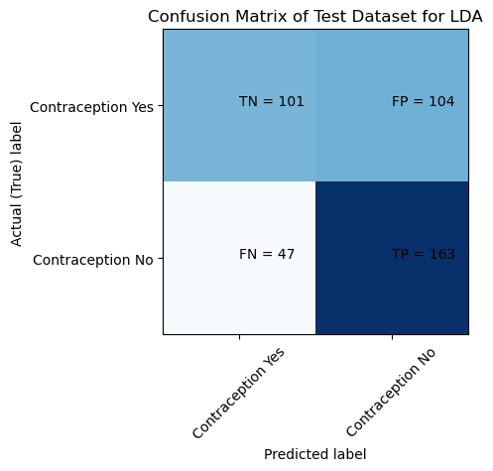

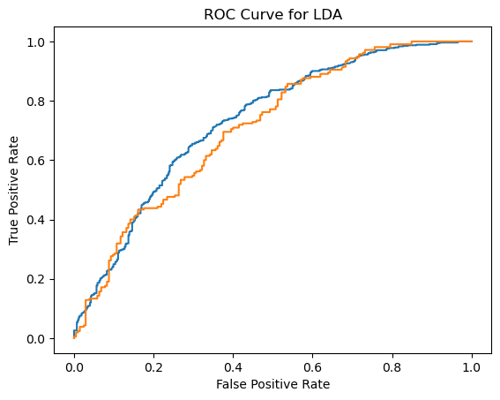

------

Classification Report of Train Data using CART:

precision recall f1-score support

0.0 0.97 1.00 0.98 424

1.0 1.00 0.97 0.99 542

accuracy 0.98 966

macro avg 0.98 0.98 0.98 966

weighted avg 0.98 0.98 0.98 966

Classification Report of Test Data using CART:

precision recall f1-score support

0.0 0.61 0.57 0.59 205

1.0 0.60 0.65 0.63 210

accuracy 0.61 415

macro avg 0.61 0.61 0.61 415

weighted avg 0.61 0.61 0.61 415

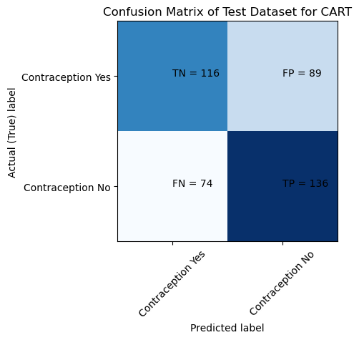

------

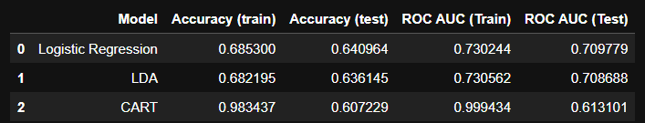

Clearly Logistic regression is the best model here when VIF is not treated.

* 1. Inference: Basis on these predictions, what are the insights and recommendations. Please explain and summarise the various steps performed in this project. There should be proper business interpretation and actionable insights present.

Answer:

Untreated model gives slightly better performance results as shown below.  
Classification Report of Train Data using Logistic Regression:

precision recall f1-score support

0.0 0.58 0.30 0.39 424

1.0 0.60 0.83 0.70 542

accuracy 0.60 966

macro avg 0.59 0.56 0.54 966

weighted avg 0.59 0.60 0.56 966

Classification Report of Test Data using Logistic Regression:

precision recall f1-score support

0.0 0.59 0.31 0.40 205

1.0 0.54 0.79 0.64 210

accuracy 0.55 415

macro avg 0.56 0.55 0.52 415

weighted avg 0.56 0.55 0.52 415

------

Classification Report of Train Data using LDA:

precision recall f1-score support

0.0 0.58 0.30 0.39 424

1.0 0.60 0.83 0.70 542

accuracy 0.60 966

macro avg 0.59 0.56 0.54 966

weighted avg 0.59 0.60 0.56 966

Classification Report of Test Data using LDA:

precision recall f1-score support

0.0 0.59 0.31 0.40 205

1.0 0.54 0.79 0.64 210

accuracy 0.55 415

macro avg 0.56 0.55 0.52 415

weighted avg 0.56 0.55 0.52 415

------

Classification Report of Train Data using CART:

precision recall f1-score support

0.0 0.57 0.37 0.45 424

1.0 0.61 0.78 0.69 542

accuracy 0.60 966

macro avg 0.59 0.57 0.57 966

weighted avg 0.59 0.60 0.58 966

Classification Report of Test Data using CART:

precision recall f1-score support

0.0 0.58 0.41 0.48 205

1.0 0.55 0.71 0.62 210

accuracy 0.56 415

macro avg 0.57 0.56 0.55 415

weighted avg 0.57 0.56 0.55 415

------

Regularized CART is slightly a better model by all metrics.

‘Husband_education’, ‘Wife_Working’ features have least importance In CART Tree where as ‘Wife_ education’, ‘Wife_age’, ‘No_of_children_born’ have high importance in the regularized decision tree.  
The decision tree can be visualized as below (Fig):  
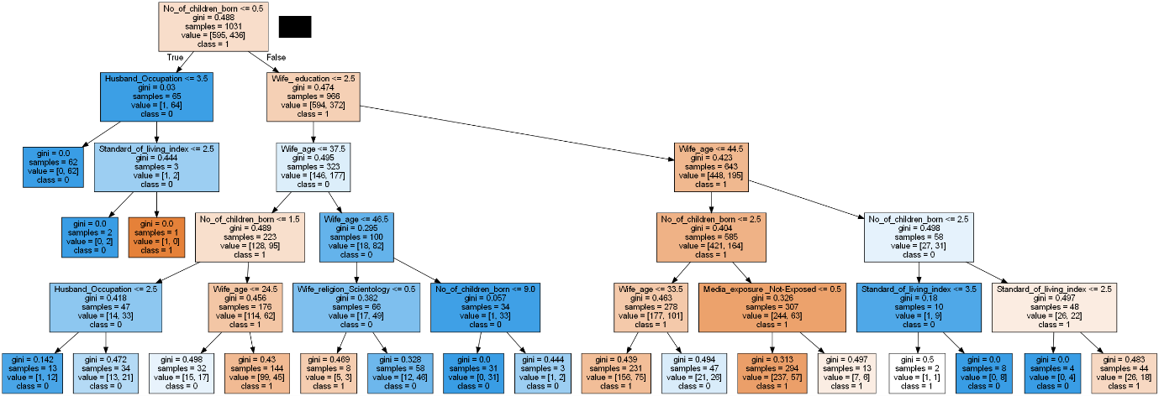

After treating features by VIF importance:

Decision trees is as below:

1. Reflection Report:

Please reflect on all that you learnt and fill this reflection report. You have to copy the link and paste it on the URL bar of your respective browser. https://docs.google.com/forms/d/e/1FAIpQLScKuVyrmTTM7Pboh0IB4YIBUbJp2NrDZcsY4SCRn3ZUkwmLGg/viewform

<Completed>